

FPT ACADEMY INTERNATIONAL

FPT – APTECH COMPUTER EDUCATION

Centre Name: ACE-HCMC-2-FPT.

Address: 590 Cach Mang Thang 8, District 3, Ho Chi Minh City, Viet Nam.

Online Antique Auction

|  |  |  |
| --- | --- | --- |
| **Supervisor.** | Mrs. Le Mong Thuy | |
| **Batch.** | T1.2209.E0 | |
| **Group.** | 1 | |
| **Serial No.** | **Enrollment Number** | **Student Name** |
| 1. | Student13733756 | Le Viet Hai Duong |
| 2. | Student1420696 | Le Thanh Thien |
| 3. | Student1420703 | Quang Dai Vi |
| 4. | Student1416070 | Nguyen Ngoc Thanh Chuong |

Month 07 Year 2023

Antique Auction Website

# ACKNOWLEDGE

Our group would like to devote this chapter to express our sincere appreciation to all those who offered us valuable assistance during in carrying out this Project.

Firstly, we owe a debt of gratitude to our dedicated instructor, MS. Le Mong Thuy, whose suggestions and encouragement helped us to overcome not only technological challenges but also psychological tension. Without her, our work could not complete successfully.

Secondly, we highly appreciate the Project Team at the Head Office, which has provided us an excellent opportunity to apply what we learned into practice. We are certain that the experiences we gained from this project will facilitate our future career greatly.

Thirdly, we would also like to express my gratitude to all the staff members of my center for not only providing me with the opportunity to work with them on this project, but also for their support and encouragement throughout the process.

Finally yet importantly, we wish to say a personal thank you to all our dear classmates and team members who are always willing to support us openly and enthusiastically.

Contents

ACKNOWLEDGE 1

INTRODUCTION 4

PROBLEM DEFINITION 4

FROM THE VIEW POINT OF VISITORS 5

What does a buyer need at an antique auction site? 5

What does a seller need at an antique auction website? 5

FROM THE VIEW POINT OF THE ADMINISTRATOR 5

CUSTOMER'S REQUIREMENTS SPECIFICATIONS (CRS) 6

**CLIENT**: Online Antique Auction 6

BUSINESS/PROJECT OBJECTIVE: 6

INPUT TO THE SYSTEM: 7

What an antique auction administrators website need to provide: 7

Customers need to provide: 7

OUTPUT FROM THE SYSTEM 8

At an antique auction website administrators will be able to 8

At an antique auction website, guests will be able to 8

What an customer/buyer will be able to 8

REVIEW 1 9

TASK SHEET REVIEW 1 9

ENTITIES & ENTITY RELATIONSHIP DIAGRAM 10

ENTITIES 10

ER Diagram 10

Property 10

Table design 12

Relationship Diagram 20

SITEMAP 21

User Data Flowchar 22

Data Flow Diagram 22

DFD Level 0 22

REVIEW 2 23

TASK SHEET REVIEW 2 23

Website Layout 23

Home and navber section 23

Introduct Section 24

Featured advertising and services section 25

Lastest Work Section 25

Short Gallery Section 26

Our Services Section 26

Testimonials Section 27

Team and Experts Section 27

Our Partner Section 28

Contact Form Section 28

Map and Footer Section 28

Screenshots 29

Home pages 29

Introduct Section 30

Latest Work Section 30

Short Gallery Section 31

Our Service Section 31

Testimonils Section 31

Team and Experts Section 32

Our Partner Section 32

Contact Form Section 32

Footer and Map Section 33

REVIEW 3 34

TASK SHEET REVIEW 3 34

# INTRODUCTION

Are you looking for a unique and valuable item to add to your collection? Do you enjoy browsing through historical artifacts and rare treasures? If so, you might be interested in visiting our antique auction website, where you can bid on a variety of items from different eras and regions. Whether you are looking for furniture, jewelry, art, books, or anything else that has a story to tell, you will find it here. Our website is easy to use and secure, and we offer fast and reliable shipping. You can also browse our catalog of past auctions and see what other collectors have bought and sold. Some of the features that make our website stand out are:

* A platform that allows sellers and buyers to interact and bid on various items of historical, artistic, or cultural value
* A catalog of items that are categorized by type, period, origin, condition, and provenance
* A system of authentication and appraisal that ensures the quality and legitimacy of the items
* A set of rules and policies that govern the bidding process, payment methods, shipping options, and dispute resolution
* A team of experts and customer service representatives that provide guidance and support to the users

# PROBLEM DEFINITION

The website aims to provide a platform for buyers and sellers of antiques to interact and bid on various items.

The website needs to ensure the authenticity, quality and value of the antiques, as well as the trustworthiness and reputation of the users.

The website also needs to handle the payment, shipping and delivery of the items, as well as the dispute resolution and customer service.

The website faces challenges such as:

* Attracting and retaining users who are interested in antiques
* Competing with other online and offline antique markets
* Dealing with fraud, theft and damage of the items
* Complying with legal and ethical regulations regarding the trade of antiques

After analyzing the project , to fulfil customer’s requirements properly, we came to conclusion that in order to achieve the best result, we should deal with following queries:

## FROM THE VIEW POINT OF VISITORS

### What does a buyer need at an antique auction site?

* A clear and detailed description of each antique item, including its history, provenance, condition, and authenticity.
* A high-quality and zoomable image gallery for each item, showing different angles and perspectives, as well as any flaws or damages.
* A secure and easy payment system that accepts various methods and currencies, and provides invoices and receipts.
* A reliable and transparent shipping and delivery service that offers tracking, insurance, and returns options.
* A user-friendly and responsive website design that allows buyers to browse, search, filter, and compare items easily and quickly.
* A customer service and support team that is available 24/7 via phone, email, or chat, and can answer any questions or concerns buyers may have.
* A feedback and rating system that allows buyers to leave reviews and ratings for sellers and items, and to see other buyers' experiences and opinions.
* A community and social media platform that allows buyers to connect with other antique enthusiasts, share their collections, get tips and advice, and participate in events and auctions.

### What does a seller need at an antique auction website?

* Contact form to register to put an antique to auction.
* The condition of the item when sent for inspection.
* Estimated inspection time.
* Post-inspection status: disqualified/passed.
* Estimated auction time if the item is approved.
* If the item is being auctioned: Current status, number of participants, number of bidders, current price.
* After the auction is completed: Payment status, expected payment time. A form to rate the quality/send a complaint regarding the auction/payment process.

## FROM THE VIEW POINT OF THE ADMINISTRATOR

User management: This function allows the site administrator to create, edit, delete, and manage user accounts, roles, and permissions. The site administrator can also monitor user activity, feedback, and ratings, as well as ban or suspend users who violate the site rules or policies.

Auction management: This function allows the site administrator to create, edit, delete, and manage auctions, lots, categories, and subcategories. The site administrator can also set the auction type (such as English, Dutch, reverse, etc.), duration, starting price, reserve price, bid increment, and other parameters. The site administrator can also monitor the bidding process, approve or reject bids, and close or cancel auctions.

Payment management: This function allows the site administrator to process and manage payments from buyers and sellers. The site administrator can also set the payment methods (such as credit card, PayPal, bank transfer, etc.), fees, commissions, taxes, and other charges. The site administrator can also issue invoices, receipts, refunds, and disputes.

Inventory management: This function allows the site administrator to track and manage the inventory of antiques on the site. The site administrator can also verify the authenticity, condition, and provenance of the antiques, as well as upload photos, videos, descriptions, and other details. The site administrator can also assign barcodes or QR codes to the antiques for easy identification and tracking.

Shipping management: This function allows the site administrator to arrange and manage the shipping of antiques from sellers to buyers. The site administrator can also set the shipping methods (such as courier, postal service, etc.), rates, insurance, and tracking. The site administrator can also handle shipping issues such as delays, damages, or losses.

Analytics and reporting: This function allows the site administrator to generate and view various reports and statistics on the site performance, user behavior, auction activity, revenue, expenses, and other metrics. The site administrator can also use analytics tools (such as Google Analytics) to optimize the site design, layout, content, SEO (search engine optimization), marketing campaigns (such as email newsletters), and other aspects.

# CUSTOMER'S REQUIREMENTS SPECIFICATIONS (CRS)

## **CLIENT**: Online Antique Auction

## BUSINESS/PROJECT OBJECTIVE:

An antique auction website is a platform where you can buy and sell antiques through a bidding process. You can browse through various categories and subcategories of antiques, such as furniture, paintings, jewelry, books, and more. You can also search for specific items by keywords, filters, or location. You can participate in different types of auctions, such as English, Dutch, reverse, and others. You can place bids on the items you like, and if you are the highest bidder at the end of the auction, you can purchase the item for the price you bid. You can also sell your own antiques on the website by creating an account, uploading photos and descriptions of your items, and setting the auction parameters. You can receive payments from buyers through secure and convenient methods, such as credit card, PayPal, or bank transfer. You can also track the shipping and delivery of your items. An antique auction website is a great way to discover and acquire rare and valuable antiques, as well as to sell your own antiques to a global audience of collectors and enthusiasts.

## INPUT TO THE SYSTEM:

### What an antique auction administrators website need to provide:

* **User registration and login**: This feature allows users to create and access their accounts on the website, where they can manage their personal information, preferences, payment methods, bids, purchases, sales, feedback, and ratings.
* **Auction listing and browsing**: This feature allows users to view and search for various auctions, lots, categories, and subcategories of antiques on the website. Users can also filter and sort the auctions by keywords, location, price range, auction type, auction status, and other criteria.
* **Auction participation and bidding**: This feature allows users to join and bid on the auctions they are interested in. Users can also view the current highest bid, the number of bidders, the time remaining, and the auction history. Users can also set automatic bids or proxy bids that will bid on their behalf up to a certain limit.
* **Auction creation and management**: This feature allows users to create and manage their own auctions on the website. Users can upload photos and descriptions of their antiques, set the auction type, duration, starting price, reserve price, bid increment, and other parameters. Users can also edit or cancel their auctions before they start or end.
* **Payment processing and security**: This feature allows users to make and receive payments securely and conveniently on the website. Users can choose from various payment methods, such as credit card, PayPal, bank transfer, etc. Users can also view their transaction history and invoices. The website should also use encryption and verification techniques to protect user data and prevent fraud.
* **Shipping and delivery**: This feature allows users to arrange and track the shipping and delivery of their antiques on the website. Users can choose from various shipping methods, rates, insurance, and tracking options. Users can also communicate with the sellers or buyers about any shipping issues or questions.
* **Customer support and feedback**: This feature allows users to contact the website’s customer support team for any queries or problems they may have. Users can also leave feedback and ratings for the sellers or buyers they have dealt with on the website. Users can also report any violations or disputes they encounter on the website.

### Customers need to provide:

* **Their personal information**: This includes their name, email address, phone number, and password. They need to provide this information to create and access their account on the website, where they can manage their bids, purchases, payments, shipping, feedback, and ratings.
* **Their payment information**: This includes their credit card number, expiration date, security code, billing address, and other details. They need to provide this information to make payments securely and conveniently on the website. They can also choose other payment methods, such as PayPal or bank transfer, if available.
* **Their shipping information**: This includes their delivery address, contact number, and other preferences. They need to provide this information to arrange and track the shipping and delivery of their antiques on the website. They can also choose from various shipping methods, rates, insurance, and tracking options.

## OUTPUT FROM THE SYSTEM

### At an antique auction website administrators will be able to

* Manage users and listings
* Monitor bids and transactions
* Verify authenticity and quality
* Resolve disputes and issues
* Generate reports and analytics

### At an antique auction website, guests will be able to

* Browse fine and decorative art, antiques, estate jewelry, coins and stamps, collectibles, and more
* Follow their favorite categories and searches
* Discover new items and auctions every day
* Read articles about antiques that have been sold and will be auctioned
* Learn about history through antiques from around the world
* View featured auction items and upcoming online auctions with catalog details and images.
* Register for free and access features such as bidding alerts, wish lists, saved searches, etc.
* Watch live streaming auctions online, real-time, at any time, on any device, and from anywhere.

### What an customer/buyer will be able to

* Sign up/login to access the website's features.
* Create and manage their own profile and preferences, such as setting their budget, favorite items, payment methods, shipping address, etc.
* Verify your identity through eKYC or ID documents easily.
* Update payment information and order information quickly.
* Follow and participate in bidding at ongoing auctions

# REVIEW 1

## TASK SHEET REVIEW 1

|  |  |  |  |
| --- | --- | --- | --- |
| **Description** | **Begin Date** | **TeamMate Name** | **Notes** |
| Acknowledgement | 20/07/2023 | Le Viet Hai Duong |  |
| Problem Statement | Le Viet Hai Duong |  |
| Requirement Specification | Le Viet Hai Duong |  |
| Function Diagram of Visitor | Nguyen Ngoc Thanh Chuong |  |
| Function Diagram of Administrator | Nguyen Ngoc Thanh Chuong |  |
| Task Sheet | Le Viet Hai Duong |  |

|  |  |
| --- | --- |
| **Date:** | |
| Signature of Instructor:  **MS. LE MONG THUY** | Signature of Team Leader:  **Le Viet Hai Duong** |

VISITOR

LOGIN AS VISITOR

|  |  |  |
| --- | --- | --- |
| Author |  | |
| Use Case Name | Login | |
| Actors | User | |
| Description | User who has registered an account can login | |
| Requirements | User provides email and password | |
| Pre - conditions | User must registered an account | |
| Post- conditions | Success: Visitor is logged in to website | |
| Fail: Refill information or send request to reset password | |
|  | Actor’s actions: | System’s responses: |
|  | 1. Visitor clicks “Login”  button on Home Page. | 2. System redirects to Login popup with the following controls:   * “Email” text field. * “Password” text field. * “Login” button.  1. System checks information. 2. System redirects to User’s   dashboard. |
| Basic flow |  |
|  | 3. Actor inputs Email and Password, then click the “Login” button. |
| Exceptions | Actor’s actions: | System’s responses: |
| Visitor access any page of administrator by URL or Actor inputs invalid email or password. | System redirects to Login page with the following controls:   * “Email” text field. * “Password” text field. * “Log in” button.   System shows message  “Invalid email or password” if they’re been inputed invalid. |

REGISTER AS VISITOR

|  |  |
| --- | --- |
| Author |  |
| Use Case Name | Register as Visitor |
| Actors | User |
| Description | User who has not registered an account can register |
| Requirements | User registers an account on the website and becomes a  member |

|  |  |  |
| --- | --- | --- |
| Pre - conditions | User provides their register information | |
| Post- conditions | Success: Visitor creates an account in the website | |
| Fail: Refill information | |
|  | Actor’s actions: | System’s responses: |
|  | 1. Visitor clicks “Login” button on Home Page. Then clicks “Register” button at the popup has appeared. | 1. System redirects to Register popup and displays Registration form with the following controls:    * “Name” text field.    * “Email” text field.    * “Password” text field.    * “Confirm password” text   field.   * + “Register” button.   + “Reset” button.  1. System inserts the account into database. 2. System automatic login the new account and redirects to User’s dashboard with success   message. |
| Basic flow |  |
|  | 3. Actor inputs register’s information, the validation is run concurrently when actor input, then click the “Register” button. |
|  | Actor’s actions: | System’s responses: |
|  | - Actor left “Name” text field blank or “Name” are input with number or special characters or less than 2 characters. | System displays message to user:  - “Name must be greater than 2 characters and not include special characters”. |
|  | - Email has already existed. | - “This Email has already existed”. |
| Exceptions | - Actor left “Email” text field blank or “Email” are input with wrong format. | - “Invalid email”. |
|  | - Actor left “Password” text field blank or “Password” length less than 8 character and does not have at least one uppercase character. | - “Password must have at least one uppercase character and not less than 8 characters”. |
|  | - Password and Confirm  password don’t match. | - “Password and Confirm password must be the same”. |

SEARCH PRODUCT:

|  |  |  |
| --- | --- | --- |
| Author |  | |
| Use Case Name | Search product | |
| Actors | Registered user/ Unregister user | |
| Description | User can search product | |
| Requirements | User provides search phrase | |
| Pre - conditions | The user must access the platform's search functionality. | |
| Post- conditions | Success: Show product that matches search phrase | |
| Fail: No product is shown | |
| Basic flow | Actor’s actions: | System’s responses: |
| 1. Actor inputs search phrase.  3. Actor clicks product’s name  in list. | 2. System shows list of product that match the search phrase. |

VIEW PRODUCT’S DETAIL:

|  |  |  |
| --- | --- | --- |
| Author |  | |
| Use Case Name | View product’s detail | |
| Actors | Registered user/ Unregister user | |
| Description | User can view product’s detail | |
| Requirements | User select product to show product’s detail | |
| Pre - conditions |  | |
| Post- conditions | Success: Display product’s detail matching the selected product. | |
| Fail: No information is shown | |
| Basic flow | Actor’s actions: | System’s responses: |
| 1. Actor inputs search phrase. | 2. System shows product’s detail. |

BID :

|  |  |  |  |  |
| --- | --- | --- | --- | --- |
| Author |  | | | |
| Use Case Name | Place a Bid (Visitor) | | | |
| Actors | Registered User | | | |
| Description | User who has registered an account can bid. Each user can only buy one bid at a time. | | | |
| Requirements | User must have access to the auction platform as guests.  User must have the privilege to place bids on items. | | | |
| Pre - conditions | User must registered an account before buy a item. User provides payment method’s information. | | | |
| Post- conditions | Success: The actor successfully purchases the item through the bid | | | |
| Fail: If the payment information is invalid or incomplete, the actor needs to refill the information. | | | |
|  | Actor’s actions: | | | System’s responses: |
|  | 1. User register an account successfully. | | | 2. The system confirms the successful registration. |
| Basic flow | 1. The user accesses the auction platform as a guest.   5.The visitor enters their bid amount in the designated input field. | | | 4. The system displays the current bid amount for the item. |
|  | 6.. The actor places a bid on the item | | | 7.If the bid is valid and higher than the current bid, the system updates the current bid amount with the visitor's bid and displays a success message.  8.If the bid is not valid or lower than the current bid, the system displays an error message and prompts the visitor to enter a higher bid. |
|  |  | | |  |
| Alternative flow | 1. Actor clicks “Back” or “X” button at Payment information table.  3. Actor clicks “Home” logo | | | 2. System redirects to Purchase page with a message: “You have cancelled the purchase”.  4. System redirects to Home Page. |
| Exceptions | Actor’s actions: | | | System’s responses: |
| Actor inputs information. | invalid | card | “Invalid card information”. |

FEEDBACK:

|  |  |  |
| --- | --- | --- |
| Author |  | |
| Use Case Name | Feedback | |
| Actors | Registered user/ Unregister user | |
| Description | A registered user can provide feedback | |
| Requirements | User must register an account | |
| Pre - conditions | User must log in to website | |
| Post- conditions | Success: The user's feedback is successfully submitted. | |
| Fail: The user fails to submit feedback due to an error or technical issue. | |
|  | Actor’s actions: | System’s responses: |
|  | 1. The user navigates to the feedback section. | 2. If the user provides valid feedback and successfully submits it, the system acknowledges the successful submission. |
| Basic flow | 3. The user provides their feedback in the designated area. | 4. If there is an error or technical issue preventing the user from submitting the feedback, the system displays an error message. |
|  | 5. The user submits the feedback. |  |

LOGOUT:

|  |  |  |
| --- | --- | --- |
| Author |  | |
| Use Case Name | Logout | |
| Actors | Registered user | |
| Description | Registered user can logout the website. | |
| Requirements | User must have an account | |
| Pre - conditions | User must login the website | |
| Post- conditions | Logout successfully. | |
| Basic flow | Actor’s actions: | System’s responses: |
| 1. Actor clicks “Account” icon  on the menu  3. Actor clicks “Logout” button | 2. System redirects to Account page.  4. System logout this account and redirects to Home Page with success message. |

EDITOR

POST :

|  |  |  |
| --- | --- | --- |
| Author |  | |
| Use Case Name | Edit Post | |
| Actors | Editor | |
| Description | Editor can edit their own posts on the platform. | |
| Requirements | Editors must have a registered account on the platform.  Editors must have logged in with their credentials.  Editors must have the privilege to edit their own posts. | |
| Pre - conditions | Authors must log in to the website with their author account. | |
| Post- conditions | Success: The editor successfully edits their post on the platform. | |
| Fail: The edit of the post fails due to an error or lack of necessary information. | |
|  | Actor’s actions: | System’s responses: |
| Basic flow | 1.The editor navigates to the "Edit Post" section in their dashboard or the specific post they want to edit.  3. The system displays the post content, allowing the author to make changes to the text, images, or other details.  6. The editor edits the post content as desired.  7.The editor clicks the "Save" button to update the post. | 2. The system displays the post content, allowing the author to make changes.  4.If the edit is successful, the system updates the post on the platform and displays a success message.  5.If the edit fails due to an error or missing information, the system displays an error message and prompts the author to try again later or fill in the missing information. |
|  |  |  |
|  |  |  |

EDIT POST:

|  |  |  |
| --- | --- | --- |
| Author |  | |
| Use Case Name | Edit Post (Editor) | |
| Actors | Editer | |
| Description | Editors can edit posts on the platform. | |
| Requirements | Editors must have a registered account on the platform.  Editors must have logged in with their credentials.  Editors must have the privilege to edit posts. | |
| Pre - conditions | Editors must log in to the website with their editor account. | |
| Post- conditions | Success: The editor successfully edits the post on the platform. | |
| Fail: The edit of the post fails due to an error or lack of necessary information. | |
|  | Actor’s actions: | System’s responses: |
| Basic flow | 1. The editor navigates to the "Edit Post" section in the editor dashboard or the specific post they want to edit.  3. The system displays the post content, allowing the editor to make changes to the text, images, or other details.  6. The editor edits the post content as desired and clicks the "Save" button to update the post. | 2. The system displays the post content, allowing the editor to make changes.  4. If the edit is successful, the system updates the post on the platform and displays a success message.  5. If the edit fails due to an error or missing information, the system displays an error message and prompts the editor to try again later or fill in the missing information. |
|  |  |  |
|  |  |  |

DELETE POST:

|  |  |  |
| --- | --- | --- |
| Author |  | |
| Use Case Name | Delete Post | |
| Actors | Editer | |
| Description | Editors can delete their own posts on the platform. | |
| Requirements | Editors must have a registered account on the platform.  Editors must have logged in with their credentials.  Editors must have the privilege to edit and delete their own posts. | |
| Pre - conditions | Editors must log in to the website with their editor account. | |
| Post- conditions | Success: The editor successfully deletes their post on the | |
| Fail: The deletion of the post fails due to an error or lack of necessary information. | |
|  | Actor’s actions: | System’s responses: |
| Basic flow | 1. The author navigates to the "Delete Post" section in their dashboard or the specific post they want to delete.  3. The system displays a confirmation message asking the author to confirm the deletion.  6The author confirms the deletion. | 2. The system displays a confirmation message asking the author to confirm the deletion.  4. If the author confirms the deletion, the system removes the post from the platform and displays a success message. |
|  |  |  |
|  |  |  |

APPRAISERS :

Login in dashboard

|  |  |  |
| --- | --- | --- |
| Author |  | |
| Use Case Name | Appraiser Login and Dashboard | |
| Actors | Appraiser | |
| Description | Appraisers can log in to the platform and access their dashboard with specific privileges. | |
| Requirements | Appraisers must have a registered account on the platform.  Appraisers must have the role of "Appraiser" to access the appraiser dashboard. | |
| Pre - conditions | Appraisers must have a valid username and password to log in. | |
| Post- conditions | Success: Appraisers successfully log in and access their dashboard. | |
| Fail: Appraisers fail to log in due to providing incorrect credentials or lack of an appraiser account. | |
|  | Actor’s actions: | System’s responses: |
| Basic flow | 1. The appraiser navigates to the platform's login page.  3. The appraiser enters their username and password in the login fields. | 2. The system verifies the provided credentials.  4. If the credentials are correct and the appraiser has the role of "Appraiser," the system redirects the appraiser to the appraiser dashboard. |
|  | 5. The appraiser clicks the "Login" button. | 6. If the credentials are incorrect or the appraiser does not have the role of "Appraiser," the system displays an error message indicating a failed login attempt. |
|  |  |  |

Create Appraiser Profile:

|  |  |  |
| --- | --- | --- |
| Author |  | |
| Use Case Name | Create Appraiser Profile | |
| Actors | Appraiser | |
| Description | Appraisers can create their profile on the platform with relevant information. | |
| Requirements | Appraisers must have a registered account on the platform.  Appraisers must have logged in with their credentials. | |
| Pre - conditions | Appraisers must log in to the website with their appraiser account. | |
| Post- conditions | Success: The appraiser successfully creates their profile on the platform. | |
| Fail: The creation of the appraiser profile fails due to missing or invalid information. | |
|  | Actor’s actions: | System’s responses: |
| Basic flow | 1. The appraiser navigates to the "Create Appraiser Profile" section in their account settings.  3. The appraiser enters the required information for their profile, such as name, contact details, qualifications, etc. | 2. If all the required information is provided and valid, the system creates the appraiser profile and displays a success message.  4. If any required information is missing or invalid, the system displays an error message and prompts the appraiser to fill in the missing information. |
|  | 5. The appraiser clicks the "Save" button to create their appraiser profile. |  |
|  |  |  |

View Products Detail

|  |  |  |
| --- | --- | --- |
| Author |  | |
| Use Case Name | View Product List (Appraiser) | |
| Actors | Appraiser | |
| Description | Appraisers can view the list of products available on the platform for verification. | |
| Requirements | Appraisers must have a registered account on the platform.  Appraisers must have logged in with their credentials. | |
| Pre - conditions | Appraisers must log in to the website with their appraiser account. | |
| Post- conditions | Success: The appraiser successfully views the list of products available for verification.  Fail: The appraiser is unable to view the product list due to an error or lack of products on the platform. | |
| Basic flow | Actor’s actions: | System’s responses: |
| 1.The appraiser logs in to the website with their appraiser account.  2. The appraiser navigates to the "View Product List" section in their appraiser dashboard. | 1. The system displays a list of products available for verification, including product names, descriptions, categories, and other relevant information.. |

Product Verification:

|  |  |  |
| --- | --- | --- |
| Author |  | |
| Use Case Name | Product Verification (Appraiser) | |
| Actors | Appraiser | |
| Description | Appraisers can create their profile on the platform with relevant information. | |
| Requirements | Appraisers can verify products by either approving or rejecting them. If rejected, the appraiser must provide a reason for the rejection.  Appraisers must have the privilege to access the product verification functionality. | |
| Pre - conditions | Appraisers must log in to the website with their appraiser account. | |
| Post- conditions | Success: The product is successfully verified, either approved or rejected with a reason for rejection. | |
| Fail: The verification of the product fails due to an error or lack of necessary information. | |
|  | Actor’s actions: | System’s responses: |
| Basic flow | 1. The appraiser navigates to the "Product Verification" section in their appraiser dashboard.  3. The appraiser selects a specific product to verify.  5.The appraiser reviews the product details and decides to approve or reject the product.  6.If the appraiser approves the product, the system updates the product status as verified.  8.If the appraiser rejects the product, the system prompts the appraiser to provide a reason for the rejection. | 2. The system displays a list of products available for verification, including product names, descriptions, categories, and other relevant information.   1. If any required information is missing or invalid, the system displays an error message and prompts the appraiser to fill in the missing information.   7 .If the appraiser approves the product, the system updates the product status as verified and displays a success message.  9.If the appraiser rejects the product and provides a reason, the system updates the product status as rejected, saves the appraiser's reason for rejection, and displays a success message. |
|  |  |  |
|  |  |  |

ADMIN

LOGIN

|  |  |  |
| --- | --- | --- |
| Author |  | |
| Use Case Name | Log in | |
| Actors | Admin | |
| Description | When admin wants to manage products, posts, users, notifications . | |
| Requirements | Admin provides email and password. | |
| Pre - conditions | Admin’s account must be exist on database | |
| Post- conditions | Success: Admin is loged into admin dashboard. | |
| Fail: Refill information | |
| Basic flow | Actor’s actions: | System’s responses: |
| 1. Actor clicks on “Login”  button  3. Actor inputs Email and Password, then clicks the “Login” button. | 2. System redirects to Login Page with the following controls:   * “Email” text field. * “Password” text field. * “Log in” button.  1. System validates information. 2. System redirects to Admin dashboard. |
|  | Actor’s actions: | System’s responses: |
|  | 1. Actor inputs invalid email or password. | 2. System redirects to Login Page with the following controls:   * “Email” text field. * “Password” text field. * “Log in” button. |
| Exceptions | 3. Actor clicks “Forgot  password”.  5. Actor inputs Email and  clicks the “Send email” button.  7. Actor open their inbox email, clicks on “Reset password” button in email.  9. Actor inputs Password, Confirm password, the validation is run concurrently when actor input data, then clicks the “Reset” button. | 4. System redirects to Send Email page with the following controls:   * “Email” text field. * “Send email” button   6. System send reset  password link to actor’s email  8. System redirects to Reset Password page with the following controls:   * “Email” readonly. * “Password” text field. * “Confirm password” text   field.  10. System saved new password to database, auto login user with new password, redirects user to dashboard with a success message. |

* VIEW PRODUCT:

|  |  |  |
| --- | --- | --- |
| Author |  | |
| Use Case Name |  | |
| Actors | Admin | |
| Description | Admin can view, add, edit, and delete products on the platform. | |
| Requirements | The admin must have appropriate privileges to access the "Manage Product" functionality. | |
| Pre - conditions | The admin must log in to the website with their admin account. | |
| Post- conditions | Success: The admin successfully manages the products on the platform, including adding, editing, and deleting products.  Fail: The admin is unable to perform any of the product management actions due to an error or lack of necessary information. | |
| Basic flow | Actor’s actions: | System’s responses: |
| 1. The admin navigates to the "Manage Product" section in the admin dashboard. | 2. The system displays a list of existing products with details.   1. If the admin successfully adds a new product, the system confirms the addition and updates the product list accordingly. 2. If the admin successfully edits an existing product, the system confirms the changes and updates the product list accordingly. 3. If the admin successfully deletes a product, the system confirms the deletion and updates the product list accordingly. |

* CREATE PRODUCT:

|  |  |  |
| --- | --- | --- |
| Author |  | |
| Use Case Name | Create Product (Admin) | |
| Actors | Admin | |
| Description | Admin can create a new product and add it to the platform. | |
| Requirements | The admin must have appropriate privileges to access the "Create Product" functionality. | |
| Pre - conditions | The admin must log in to the website with their admin account. | |
| Post- conditions | Success: The new product is successfully created and added to the platform. | |
| Basic flow | Actor’s actions: | System’s responses: |
| 1. The admin navigates to the "Create Product" section in the admin dashboard. | 2. If all the required information is provided and valid, the system creates the new product and displays a success message. |

* : UPDATE PRODUCT:

|  |  |  |
| --- | --- | --- |
| Author |  | |
| Use Case Name | Update Product (Admin) | |
| Actors | Admin | |
| Description | Admin can update the information of an existing product on the platform. | |
| Requirements | The admin must provide the updated information for the product. | |
| Pre - conditions | Admin is logged in admin dashboard. | |
| Post- conditions | Success: The product's information is successfully updated on the platform. | |
| Fail: Refill information | |
|  | Actor’s actions: | System’s responses: |
|  | 1. The admin navigates to the "Update Product" section in the admin dashboard. | 2. If all the required information is provided and valid, the system updates the product's information and displays a success message. |
| Basic flow | 3. The admin selects the product they want to update from the list of existing products. | 4. If any required information is missing or invalid, the system displays an error message and prompts the admin to fill in the missing information. |
|  | 5. The admin edits the necessary information for the product, such as product name, description, category, price, and image. | 1. System delete product into database. |

* DELETE PRODUCT:

|  |  |  |
| --- | --- | --- |
| Author |  | |
| Use Case Name | Delete Product (Admin) | |
| Actors | Admin | |
| Description | Admin can delete a product from the platform. | |
| Requirements | The admin must have appropriate privileges to access the "Delete Product" functionality.  The admin must be able to select a specific product to delete. | |
| Pre - conditions | Admin is logged in admin dashboard. | |
| Post- conditions | Success: The product is successfully deleted from the platform. | |
| Fail: The deletion of the product fails due to an error or the product not being available.z | |
|  | Actor’s actions: | System’s responses: |
|  | 1. The admin navigates to the "Manage Product" section in the admin dashboard. | 2. The system displays a list of existing products with details. |
| Basic flow | 3. The system displays a list of existing products with details. | 4. The system prompts the admin to confirm the deletion of the product. |
|  | 5. The admin selects a specific product to delete | 1. System delete product into database. 2. System redirects to product page and display a success message. |

## ENTITIES & ENTITY RELATIONSHIP DIAGRAM

### ENTITIES

User

Product

Auction Seesion

Role

### ER Diagram

### Property

1.addresses

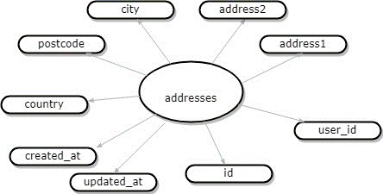

2.appraisers

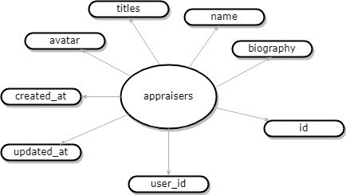

3.aution-sesstion

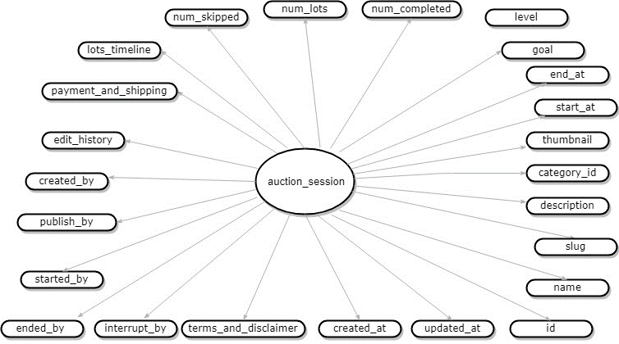

4.bided-histories

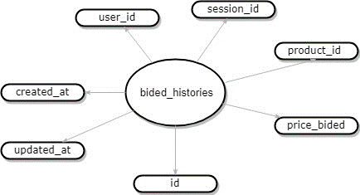

5.categories

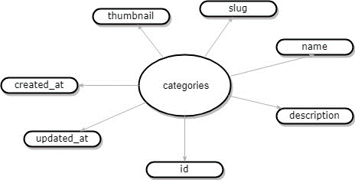

6.contact-form

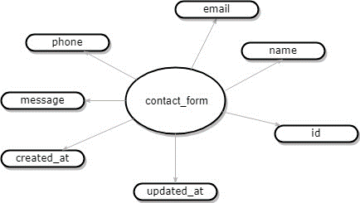

7.edit-session-history

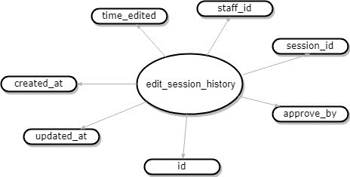

8.era-and-country

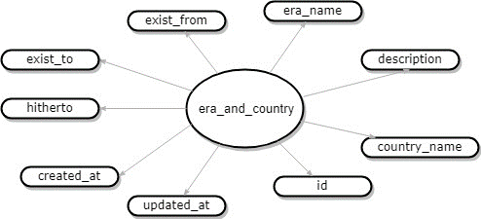

9.failed-job

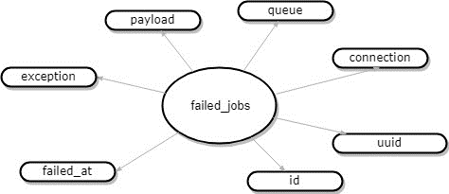

10.feedback

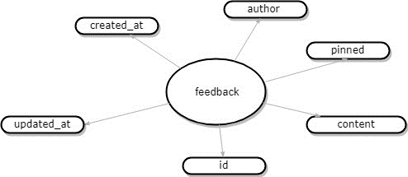

11.migrations

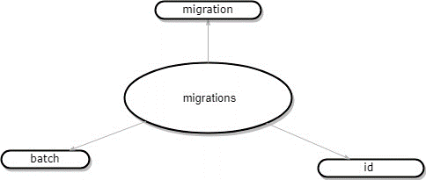

12.password-reset-tokens

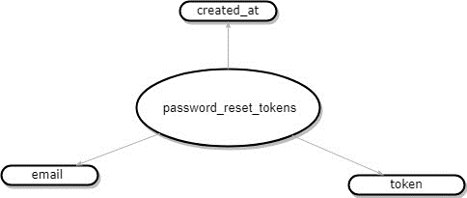

13.personal-access-tokens

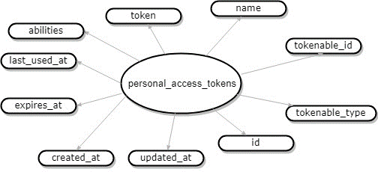

14.post

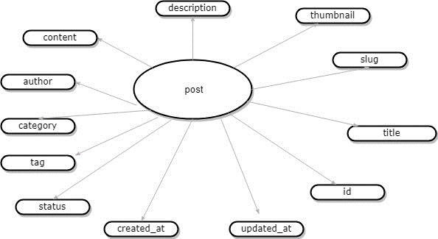

15.post-categories

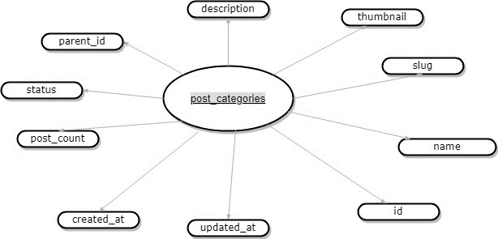

16.products

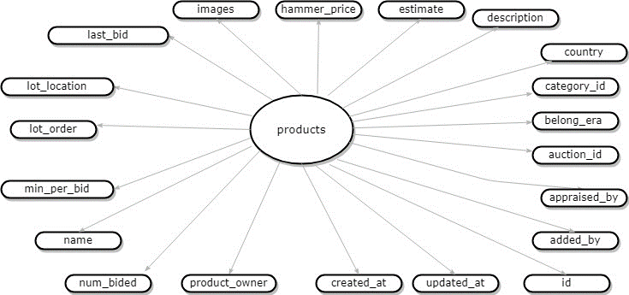

17.products-owners

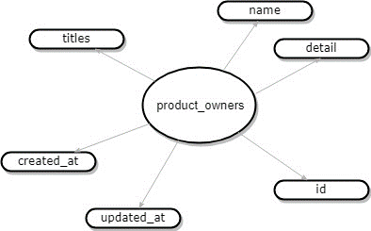

18.session

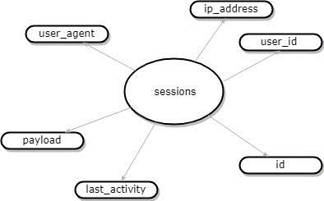

19.teams

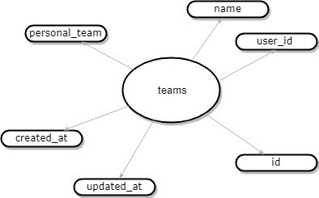

20.team-invitations

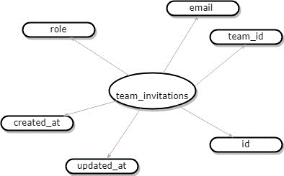

21.team-user

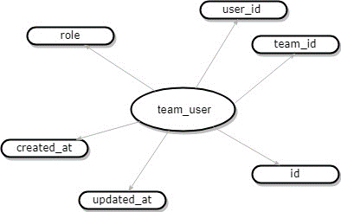

22.terms-and-disclaimer

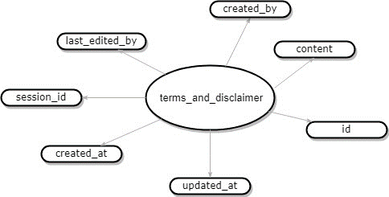

23.users

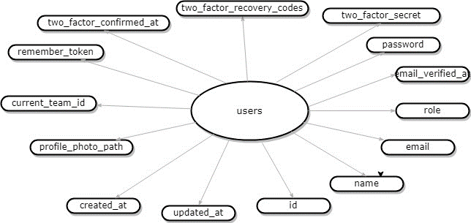

### Table design

### 

|  |  |  |  |  |  |  |
| --- | --- | --- | --- | --- | --- | --- |
| **1 addresses** | | | | | | |
| **Cột** | **Kiểu** | **Thuộc tính** | **Null** | **Mặc định** | **Thêm** | **Liên kết tới** |
| id | bigint | UNSIGNED | Không |  | auto_inc rement |  |
| user_id | bigint | UNSIGNED | Có | NULL |  |  |
| address1 | text |  | Không |  |  |  |
| address2 | text |  | Không |  |  |  |
| city | text |  | Có |  |  |  |
| post_code | text |  | Có |  |  |  |
| country | text |  | Không |  |  |  |
| created_at | timestamp |  | Có | NULL |  |  |
| updated_at | timestamp |  | Có | NULL |  |  |

### 

|  |  |  |  |  |  |  |
| --- | --- | --- | --- | --- | --- | --- |
| **2 appraisers** | | | | | | |
| **Cột** | **Kiểu** | **Thuộc tính** | **Null** | **Mặc định** | **Thêm** | **Liên kết tới** |
| id | bigint | UNSIGNED | Không |  | auto_inc rement |  |
| biography | text |  | Không |  |  |  |
| name | text |  | Không |  |  |  |
| avatar | text |  | Không |  |  |  |
| titles | timestamp |  | Không |  |  |  |
| created_at | timestamp |  | Có | NULL |  |  |
| updated_at | text |  | Có | NULL |  |  |
| user_id | bigint | UNSIGNED | Có | NULL |  |  |

|  |  |  |  |  |  |  |
| --- | --- | --- | --- | --- | --- | --- |
| **3 auction_session** | | | | | | |
| **Cột** | **Kiểu** | **Thuộc tính** | **Null** | **Mặc định** | **Thêm** | **Liên kết tới** |
| id | bigint | UNSIGNED | Không |  | auto_inc rement |  |
| name | text |  | Không |  |  | -> users.id ON UPDATE RESTRICT ON DELETE RESTRICT |
| slug | text |  | Không |  |  |  |
| description | text |  | Không |  |  | -> edit_session_his tory.id ON UPDATE RESTRICT ON DELETE RESTRICT |
| category_id | bigint | UNSIGNED | Có | NULL |  |  |
| thumbnail | text |  | Không |  |  | -> users.id ON UPDATE RESTRICT ON DELETE RESTRICT |
| start_at | timestamp |  | Có | NULL |  |  |
| end_at | timestamp |  | Có | NULL |  | -> users.id ON UPDATE RESTRICT ON DELETE RESTRICT |
| goal | text |  | Không |  |  |  |
| level | bigint | UNSIGNED | Không |  |  |  |
| num_completed | int |  | Không |  |  |  |
| num_lots | int |  | Không |  |  |  |
| num_skipped | int |  | Không |  |  |  |
| lots_timeline | longtext |  | Có | NULL |  |  |
| payment_and_shipping | text |  | Có | NULL |  |  |
| edit_history | bigint | UNSIGNED | Có | NULL |  | -> users.id ON UPDATE RESTRICT ON DELETE RESTRICT |
| created_by | bigint | UNSIGNED | Có | NULL |  |  |
| pushlish_by | bigint | UNSIGNED | Có | NULL |  | -> users.id ON UPDATE RESTRICT ON DELETE RESTRICT |
| started_by | bigint | UNSIGNED | Có | NULL |  | -> terms_and_discl aimer.id ON UPDATE RESTRICT ON DELETE RESTRICT |
| ended_by | bigin | UNSIGNED | Có | NULL |  |  |
| interrupt_by | biginmp | UNSIGNED | Có | NULL |  |  |
| terms_and_disclaimer | bigin | UNSIGNED | Có | NULL |  |  |
| created_at | timestamp |  | Có | NULL |  |  |
| updated_at | timestamp |  | Có | NULL |  |  |

|  |  |  |  |  |  |  |
| --- | --- | --- | --- | --- | --- | --- |
| **4 bided_histories** | | | | | | |
| **Cột** | **Kiểu** | **Thuộc tính** | **Null** | **Mặc định** | **Thêm** | **Liên kết tới** |
| id | bigint | UNSIGNED | Không |  | auto_inc rement |  |
| price_bided | bigint |  | Không |  |  |  |
| product_id | bigint | UNSIGNED | Không |  |  | -> products.id ON UPDATE RESTRICT ON DELETE RESTRICT |
| session_id | bigint | UNSIGNED | Không |  |  | -> auction_session.id ON UPDATE RESTRICT ON DELETE RESTRICT |
| user_id | bigint | UNSIGNED | Không |  |  | -> users.id ON UPDATE RESTRICT ON DELETE RESTRICT |
| created_at | timestamp |  | Có | NULL |  |  |
| updated_at | timestamp |  | Có | NULL |  |  |

|  |  |  |  |  |  |  |
| --- | --- | --- | --- | --- | --- | --- |
| **5 categories** | | | | | | |
| **Cột** | **Kiểu** | **Thuộc tính** | **Null** | **Mặc định** | **Thêm** | **Liên kết tới** |
| id | bigint | UNSIGNED | Không |  | auto_inc rement |  |
| description | text |  | Không |  |  |  |
| name | text |  | Khôn g |  |  |  |
| slug | text |  | Không |  |  |  |
| thumbnail | text |  | Không |  |  |  |
| created_at | timestamp |  | Có | NULL |  |  |
| updated_at | timestamp |  | Có | NULL |  |  |

|  |  |  |  |  |  |  |
| --- | --- | --- | --- | --- | --- | --- |
| **6 contact_form** | | | | | | |
| **Cột** | **Kiểu** | **Thuộc tính** | **Null** | **Mặc định** | **Thêm** | **Liên kết tới** |
| id | bigint | UNSIGNED | Không |  | auto_inc rement |  |
| name | varchar(255) |  | Không |  |  |  |
| email | varchar(255) |  | Khôn g |  |  |  |
| phone | varchar(255) |  | Không |  |  |  |
| message | text |  | Không |  |  |  |
| created_at | timestamp |  | Có | NULL |  |  |
| updated_at | timestamp |  | Có | NULL |  |  |

|  |  |  |  |  |  |  |
| --- | --- | --- | --- | --- | --- | --- |
| **7 edit_session_history** | | | | | | |
| **Cột** | **Kiểu** | **Thuộc tính** | **Null** | **Mặc định** | **Thêm** | **Liên kết tới** |
| id | bigint | UNSIGNED | Không |  | auto_inc rement |  |
| approve_by | bigint | UNSIGNED | Không |  |  |  |
| session_id | bigint | UNSIGNED | Khôn g |  |  |  |
| staff_id | bigint | UNSIGNED | Không |  |  |  |
| time_edited | time |  | Không |  |  |  |
| created_at | timestamp |  | Có | NULL |  |  |
| updated_at | timestamp |  | Có | NULL |  |  |

|  |  |  |  |  |  |  |
| --- | --- | --- | --- | --- | --- | --- |
| **8 era_and_country** | | | | | | |
| **Cột** | **Kiểu** | **Thuộc tính** | **Null** | **Mặc định** | **Thêm** | **Liên kết tới** |
| id | bigint | UNSIGNED | Không |  | auto_inc rement |  |
| country_name | text |  | Không |  |  |  |
| description | text |  | Khôn g |  |  |  |
| era_name | text |  | Không |  |  |  |
| exist_from | year |  | Không |  |  |  |
| exist_to | year |  | Khôn g |  |  |  |
| hitherto | tinyint(1) |  | Không |  |  |  |
| created_at | timestamp |  | Có | NULL |  |  |
| updated_at | timestamp |  | Có | NULL |  |  |

|  |  |  |  |  |  |  |
| --- | --- | --- | --- | --- | --- | --- |
| **9 failed_jobs** | | | | | | |
| **Cột** | **Kiểu** | **Thuộc tính** | **Null** | **Mặc định** | **Thêm** | **Liên kết tới** |
| id | bigint | UNSIGNED | Không |  | auto_inc rement |  |
| uuid | varchar(255) |  | Không |  |  |  |
| connection | text |  | Khôn g |  |  |  |
| queue | text |  | Không |  |  |  |
| payload | longtext |  | Không |  |  |  |
| exception | longtext |  | Khôn g |  |  |  |
| failed_at | timestamp |  | Không | CURREN T_TIMES TAMP | DEFAULT _GENER ATED |  |

|  |  |  |  |  |  |  |
| --- | --- | --- | --- | --- | --- | --- |
| **10 feedback** | | | | | | |
| **Cột** | **Kiểu** | **Thuộc tính** | **Null** | **Mặc định** | **Thêm** | **Liên kết tới** |
| id | bigint | UNSIGNED | Không |  | auto_inc rement |  |
| content | text |  | Không |  |  |  |
| pinned | tinyint |  | Khôn g | 0 |  |  |
| author | bigint | UNSIGNED | Không |  |  | -> users.id ON UPDATE RESTRICT ON DELETE RESTRICT |
| created_at | timestamp |  | Có | NULL |  |  |
| updated_at | timestamp |  | Có | NULL |  |  |

|  |  |  |  |  |  |  |
| --- | --- | --- | --- | --- | --- | --- |
| **11 migrations** | | | | | | |
| **Cột** | **Kiểu** | **Thuộc tính** | **Null** | **Mặc định** | **Thêm** | **Liên kết tới** |
| id | int | UNSIGNED | Không |  | auto_inc rement |  |
| migration | varchar(255) |  | Không |  |  |  |
| batch | int |  | Không |  |  |  |

|  |  |  |  |  |  |  |
| --- | --- | --- | --- | --- | --- | --- |
| **12 password_reset_tokens** | | | | | | |
| **Cột** | **Kiểu** | **Thuộc tính** | **Null** | **Mặc định** | **Thêm** | **Liên kết tới** |
| email | varchar(255) |  | Không |  |  |  |
| token | varchar(255) |  | Không |  |  |  |
| created_at | timestamp |  | Có | NULL |  |  |

|  |  |  |  |  |  |  |
| --- | --- | --- | --- | --- | --- | --- |
| **13 personal_access_tokens** | | | | | | |
| **Cột** | **Kiểu** | **Thuộc tính** | **Null** | **Mặc định** | **Thêm** | **Liên kết tới** |
| id | bigint | UNSIGNED | Không |  | auto_inc rement |  |
| tokenable_type | varchar(255) |  | Không |  |  |  |
| tokenable_id | bigint | UNSIGNED | Khôn g |  |  |  |
| name | varchar(255) |  | Không |  |  |  |
| token | varchar(64) |  | Không |  |  |  |
| abilities | text |  | Có | NULL |  |  |
| last_used_at | timestamp |  | Có | NULL |  |  |
| expires_at | timestamp |  | Có | NULL |  |  |
| created_at | timestamp |  | Có | NULL |  |  |
| updated_at | timestamp |  | Có | NULL |  |  |

|  |  |  |  |  |  |  |
| --- | --- | --- | --- | --- | --- | --- |
| **14 post** | | | | | | |
| **Cột** | **Kiểu** | **Thuộc tính** | **Null** | **Mặc định** | **Thêm** | **Liên kết tới** |
| id | bigint | UNSIGNED | Không |  | auto_inc rement |  |
| title | text |  | Không |  |  |  |
| slug | text |  | Khôn g |  |  |  |
| thumbnail | text |  | Không |  |  |  |
| description | text |  | Không |  |  |  |
| content | text |  | Khôn g |  |  |  |
| author | bigint | UNSIGNED | Không |  |  | -> users.id ON UPDATE RESTRICT ON DELETE RESTRICT |
| category | bigint | UNSIGNED | Không |  |  | -> post_categories.id ON UPDATE RESTRICT ON DELETE RESTRICT |
| tag | text |  | Không |  |  |  |
| status | text |  | Không |  |  |  |
| created_at | timestamp |  | Có | NULL |  |  |
| updated_at | timestamp |  | Có | NULL |  |  |

|  |  |  |  |  |  |  |
| --- | --- | --- | --- | --- | --- | --- |
| **15 post_categories** | | | | | | |
| **Cột** | **Kiểu** | **Thuộc tính** | **Null** | **Mặc định** | **Thêm** | **Liên kết tới** |
| id | bigint | UNSIGNED | Không |  | auto_inc rement |  |
| name | text |  | Không |  |  |  |
| slug | text |  | Khôn g |  |  |  |
| thumbnail | text |  | Không |  |  |  |
| description | text |  | Không |  |  |  |
| parent_id | bigint | UNSIGNED | Khôn g |  |  |  |
| status | text |  | Không |  |  |  |
| post_count | text |  | Không |  |  |  |
| created_at | timestamp |  | Có | NULL |  |  |
| updated_at | timestamp |  | Có | NULL |  |  |

|  |  |  |  |  |  |  |
| --- | --- | --- | --- | --- | --- | --- |
| **16 product_owners** | | | | | | |
| **Cột** | **Kiểu** | **Thuộc tính** | **Null** | **Mặc định** | **Thêm** | **Liên kết tới** |
| id | bigint | UNSIGNED | Không |  | auto_inc rement |  |
| detail | text |  | Không |  |  |  |
| name | text |  | Khôn g |  |  |  |
| titles | text |  | Không |  |  |  |
| created_at | timestamp |  | Có | NULL |  |  |
| updated_at | timestamp |  | Có | NULL |  |  |

|  |  |  |  |  |  |  |
| --- | --- | --- | --- | --- | --- | --- |
| **17 products** | | | | | | |
| **Cột** | **Kiểu** | **Thuộc tính** | **Null** | **Mặc định** | **Thêm** | **Liên kết tới** |
| id | bigint | UNSIGNED | Không |  | auto_inc rement |  |
| added_by | bigint | UNSIGNED | Không |  |  | -> users.id ON UPDATE RESTRICT ON DELETE RESTRICT |
| appraised_by | bigint | UNSIGNED | Không |  |  | -> appraisers.id ON UPDATE RESTRICT ON DELETE RESTRICT |
| auction_id | bigint | UNSIGNED | Không |  |  | -> auction_session.id ON UPDATE RESTRICT ON DELETE RESTRICT |
| belong_era | bigint | UNSIGNED | Không |  |  | -> era_and_country.id ON UPDATE RESTRICT ON DELETE RESTRICT |
| category_id | bigint | UNSIGNED | Không |  |  | -> categories.id ON UPDATE RESTRICT ON DELETE RESTRICT |
| country | bigint | UNSIGNED | Không |  |  | -> era_and_country.id ON UPDATE RESTRICT ON DELETE RESTRICT |
| description | text |  | Không |  |  |  |
| estimate | json |  | Không |  |  |  |
| hammer_price | bigint |  | Khôn g |  |  |  |
| images | text |  | Không |  |  |  |
| last_bid | bigint |  | Không |  |  |  |
| lot_location | text |  | Không |  |  |  |
| lot_order | int |  | Không |  |  |  |
| min_per_bid | int |  | Không |  |  |  |
| name | text |  | Không |  |  |  |
| num_bided | int |  | Không |  |  |  |
| product_owner | bigint | UNSIGNED | Không |  |  | -> product_owners.id ON UPDATE RESTRICT ON DELETE RESTRICT |
| created_at | timestamp |  | Có | NULL |  |  |
| updated_at | timestamp |  | Có | NULL |  |  |

|  |  |  |  |  |  |  |
| --- | --- | --- | --- | --- | --- | --- |
| **18 sessions** | | | | | | |
| **Cột** | **Kiểu** | **Thuộc tính** | **Null** | **Mặc định** | **Thêm** | **Liên kết tới** |
| id | varchar(255) |  | Không |  |  |  |
| user_id | bigint | UNSIGNED | Có | NULL |  |  |
| ip_address | varchar(45) |  | Có | NULL |  |  |
| user_agent | text |  | Có | NULL |  |  |
| payload | longtext |  | Không |  |  |  |
| last_activity | int |  | Không |  |  |  |

|  |  |  |  |  |  |  |
| --- | --- | --- | --- | --- | --- | --- |
| **19 team_invitations** | | | | | | |
| **Cột** | **Kiểu** | **Thuộc tính** | **Null** | **Mặc định** | **Thêm** | **Liên kết tới** |
| id | bigint | UNSIGNED | Không |  | auto_inc rement |  |
| team_id | bigint | UNSIGNED | Không |  |  | -> teams.id ON UPDATE RESTRICT ON DELETE CASCADE |
| email | varchar(255) |  | Không |  |  |  |
| role | varchar(255) |  | Có | NULL |  |  |
| created_at | timestamp |  | Có | NULL |  |  |
| updated_at | timestamp |  | Có | NULL |  |  |

|  |  |  |  |  |  |  |
| --- | --- | --- | --- | --- | --- | --- |
| **20 team_user** | | | | | | |
| **Cột** | **Kiểu** | **Thuộc tính** | **Null** | **Mặc định** | **Thêm** | **Liên kết tới** |
| id | bigint | UNSIGNED | Không |  | auto_inc rement |  |
| team_id | bigint | UNSIGNED | Không |  |  |  |
| user_id | bigint | UNSIGNED | Khôn g |  |  |  |
| role | varchar(255) |  | Có | NULL |  |  |
| created_at | timestamp |  | Có | NULL |  |  |
| updated_at | timestamp |  | Có | NULL |  |  |

|  |  |  |  |  |  |  |
| --- | --- | --- | --- | --- | --- | --- |
| **21 teams** | | | | | | |
| **Cột** | **Kiểu** | **Thuộc tính** | **Null** | **Mặc định** | **Thêm** | **Liên kết tới** |
| id | bigint | UNSIGNED | Không |  | auto_inc rement |  |
| user_id | bigint | UNSIGNED | Không |  |  |  |
| name | varchar(255) |  | Khôn g |  |  |  |
| personal_team | tinyint(1) |  | Không |  |  |  |
| created_at | timestamp |  | Có | NULL |  |  |
| updated_at | timestamp |  | Có | NULL |  |  |

|  |  |  |  |  |  |  |
| --- | --- | --- | --- | --- | --- | --- |
| **22 terms_and_disclaimer** | | | | | | |
| **Cột** | **Kiểu** | **Thuộc tính** | **Null** | **Mặc định** | **Thêm** | **Liên kết tới** |
| id | bigint | UNSIGNED | Không |  | auto_inc rement |  |
| content | text |  | Không |  |  |  |
| created_by | bigint | UNSIGNED | Khôn g |  |  |  |
| last_edited_ by | bigint | UNSIGNED | Không |  |  |  |
| session_id | bigint | UNSIGNED | Không |  |  |  |
| created_at | timestamp |  | Có | NULL |  |  |
| updated_at | timestamp |  | Có | NULL |  |  |

|  |  |  |  |  |  |  |
| --- | --- | --- | --- | --- | --- | --- |
| **23 users** | | | | | | |
| **Cột** | **Kiểu** | **Thuộc tính** | **Null** | **Mặc định** | **Thêm** | **Liên kết tới** |
| id | bigint | UNSIGNED | Không |  | auto_inc rement |  |
| name | varchar(255) |  | Không |  |  |  |
| email | varchar(255) |  | Khôn g |  |  |  |
| email_verifi ed_at | timestamp |  | Có | NULL |  |  |
| password | varchar(255) |  | Không |  |  |  |
| two_factor_secret | text |  | Có | NULL |  |  |
| two_factor_recovery_codes | text |  | Có | NULL |  |  |
| two_factor_confirmed_at | timestamp |  | Có | NULL |  |  |
| remember_token | varchar(100) |  | Có | NULL |  |  |
| current_tea m_id | bigint | UNSIGNED | Có | NULL |  |  |
| profile_photo_path | varchar(2048) |  | Có | NULL |  |  |
| created_at | timestamp |  | Có | NULL |  |  |
| updated_at | timestamp |  | Có | NULL |  |  |

### Relationship Diagram

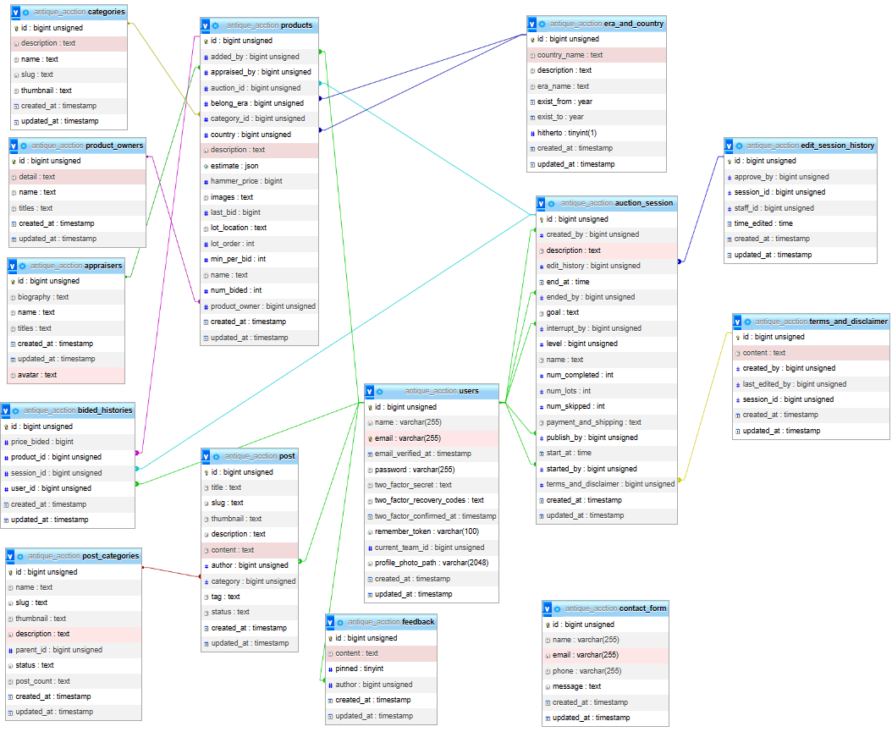

## SITEMAP

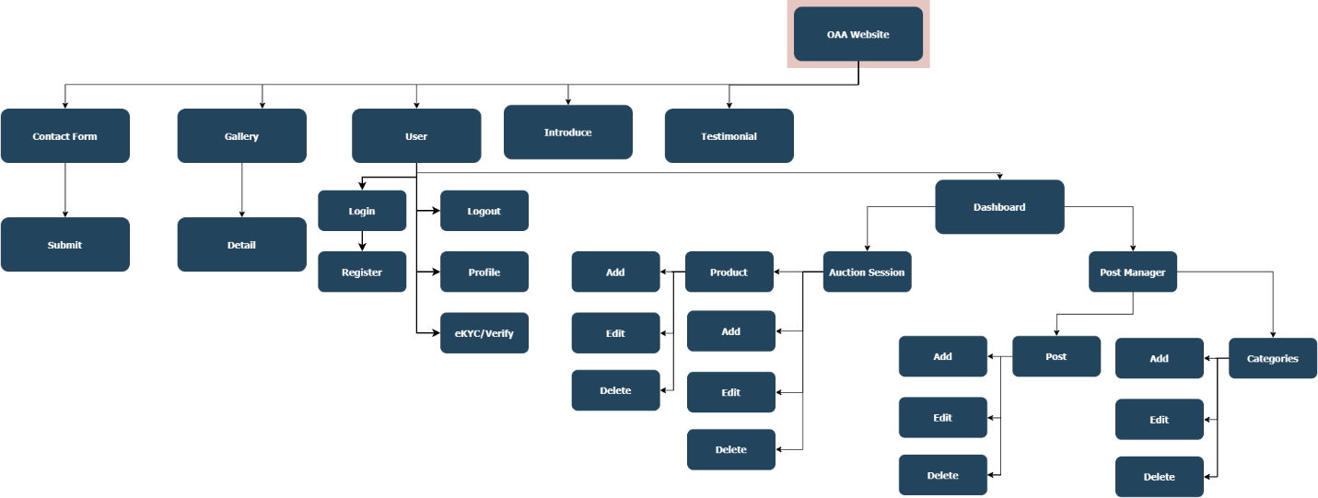

## User Data Flowchar

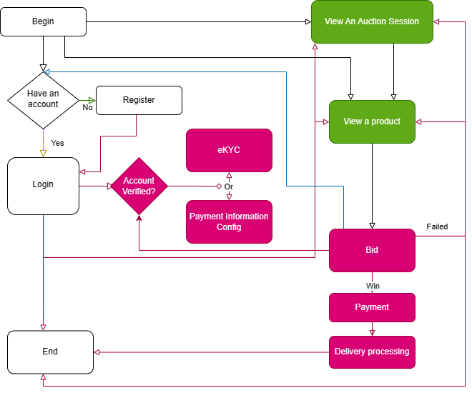

## Data Flow Diagram

### DFD Level 0

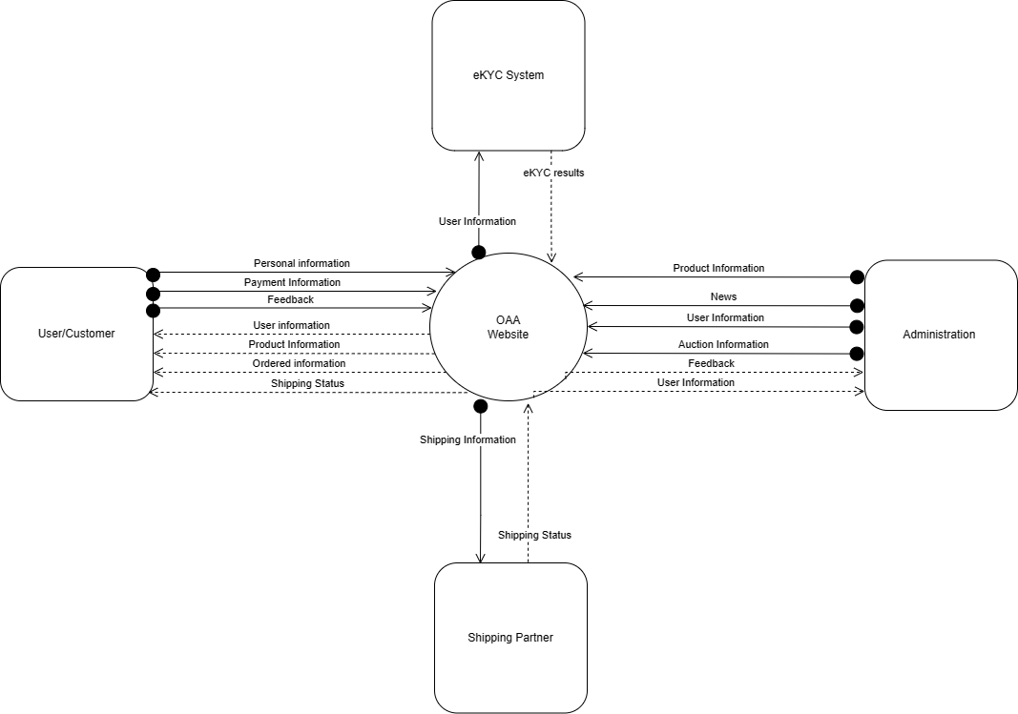

# REVIEW 2

## TASK SHEET REVIEW 2

|  |  |  |  |  |
| --- | --- | --- | --- | --- |
| **No.** | **Description** | **Begin Date** | **TeamMate Name** | **Notes** |
| 1 | Entities and ER Diagram | 20/07/2023 | Le Viet Hai Duong |  |
| 2 | Table design and Relationship diagram | Le Viet Hai Duong  Nguyen Ngoc Thanh Chuong |  |
| 3 | Sitemap | Le Viet Hai Duong |  |
| 5 | Task Sheet | Le Viet Hai Duong |  |

|  |  |
| --- | --- |
| **Date:** | |
| Signature of Instructor:  **MS. LE MONG THUY** | Signature of Team Leader:  **Le Viet Hai Duong** |

## Website Layout

### Home and navber section

Shows a navigation bar with logo located in the upper left corner. Next are the link-items in this navigation bar to link to other components of the website. Finally in the upper right corner are icons that lead to social networking sites owned by us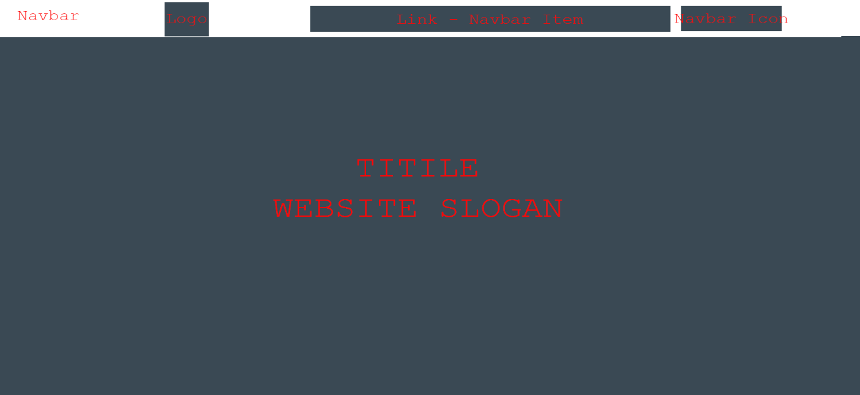

The site also has flexible support for mobile. In the mobile interface, the logo will still be displayed in the upper right corner. Along with that is a button with the hamburger menu icon. This button has the function of collapsing/expanding nav-items to make the website in moblie clearer.



### Introduct Section

This section will show the main title of the website as well as the working principle and short introduction

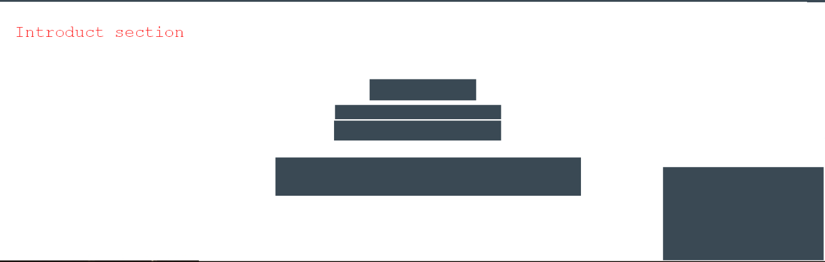

### Featured advertising and services section

This section will display our featured service and/or advertise third party services



### Lastest Work Section

This section will show our completed products/auctions. It will include 2 separate tabs showing the latest products and the most viewed/favorite products

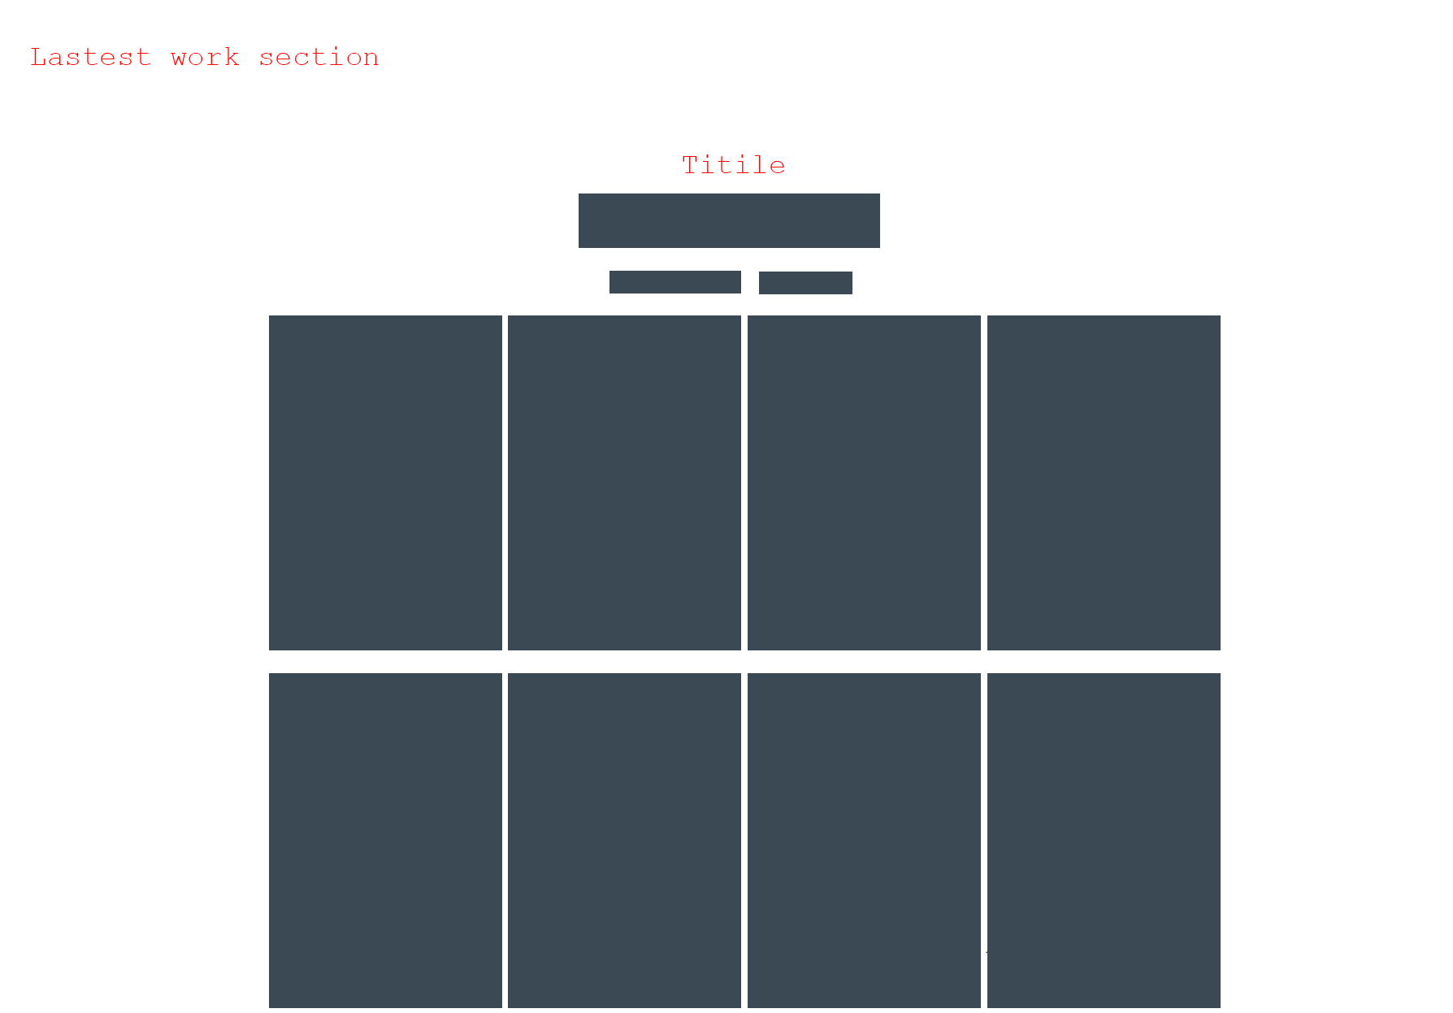

### Short Gallery Section

This will display an image gallery as a slider. These images are of the products that have been/are/will be auctioned by us.



### Our Services Section

In this section, the services provided by us or 3rd parties will be displayed. They are pictures/articles about the services provided.

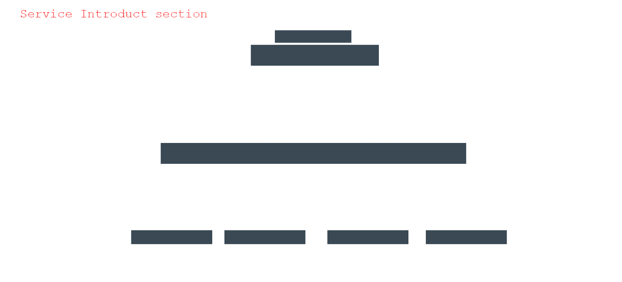

### Testimonials Section

The Testimonials section is where the testimonials of experts, customers and many antique collectors speak about us. Those are the evaluations of our quality, service and ability to work. Arguably this is our most proud area on this site.



### Team and Experts Section

This section is where you will find our experts, professionals, as well as our proud collaborators. This place will tell you who you will work with if using our services!.



### Our Partner Section

Of course, we wouldn't be able to function without these amazing partners. You will find out which third-party service providers are working with us in this section.



### Contact Form Section

Do you have antiques that need to be sold but don't know what to do? Or you simply want to use our antique valuation service. Or complain or contact for business cooperation? We welcome your much-awaited messages. Contact us through the form in this section!



### Map and Footer Section

We have our headquarters where we work and welcome valuable customers like you. For your convenience, this section will be an embedded map through the google map api.

And finally the footer section with our logo in the bottom left corner. In the middle are icons that link to our official social networking sites.



## Screenshots

### Home pages



### Introduct Section

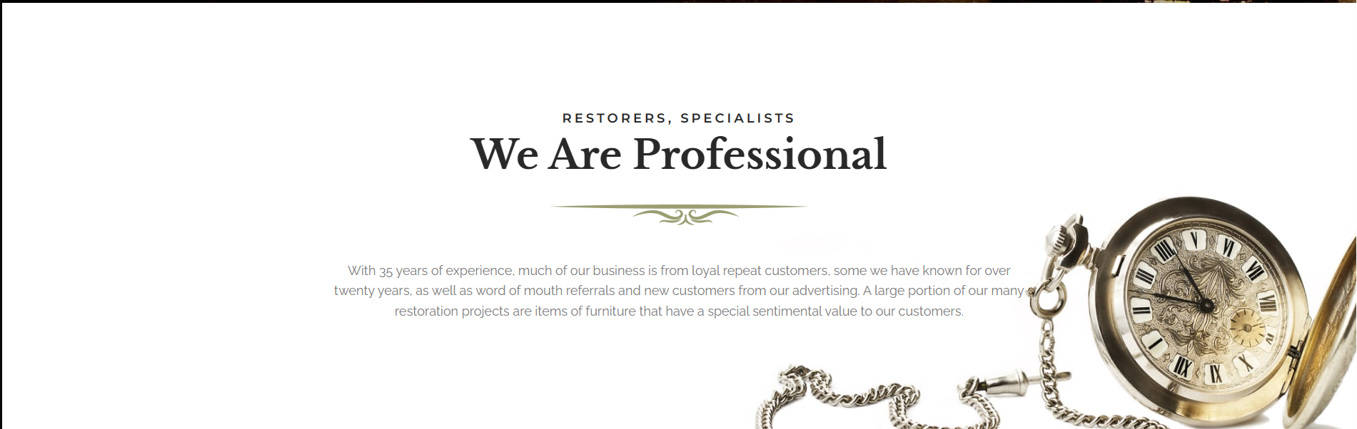



### Latest Work Section

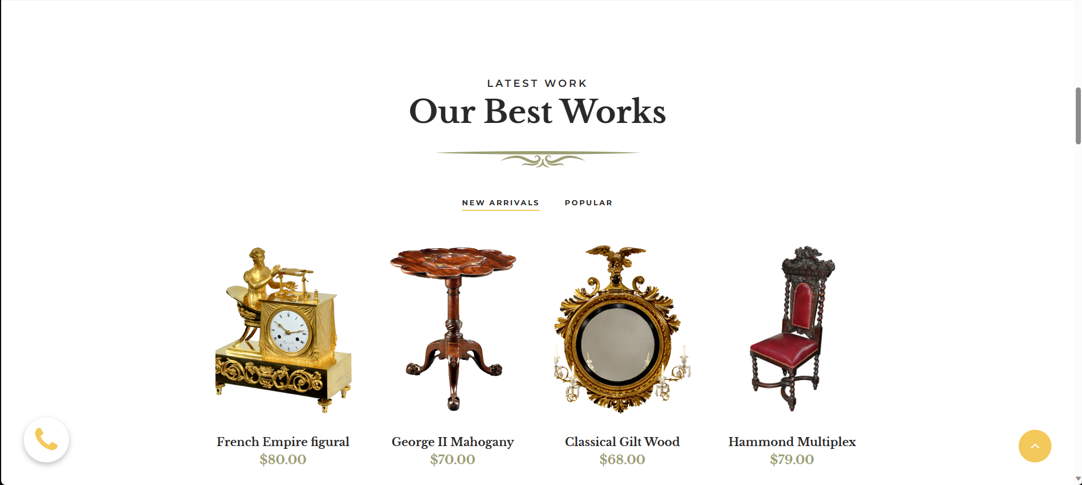

### Short Gallery Section

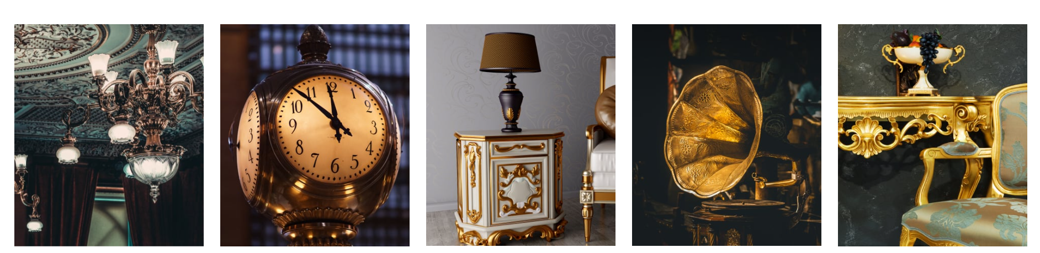

### Our Service Section

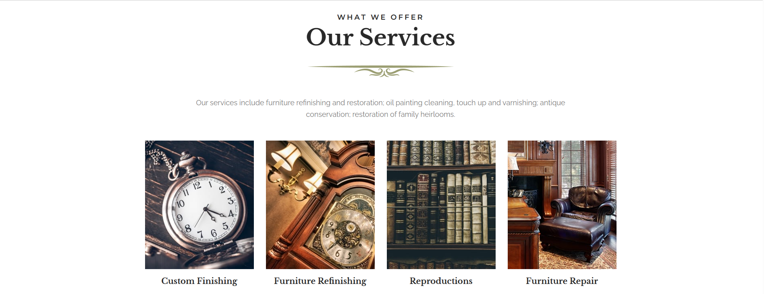

### Testimonils Section



### Team and Experts Section

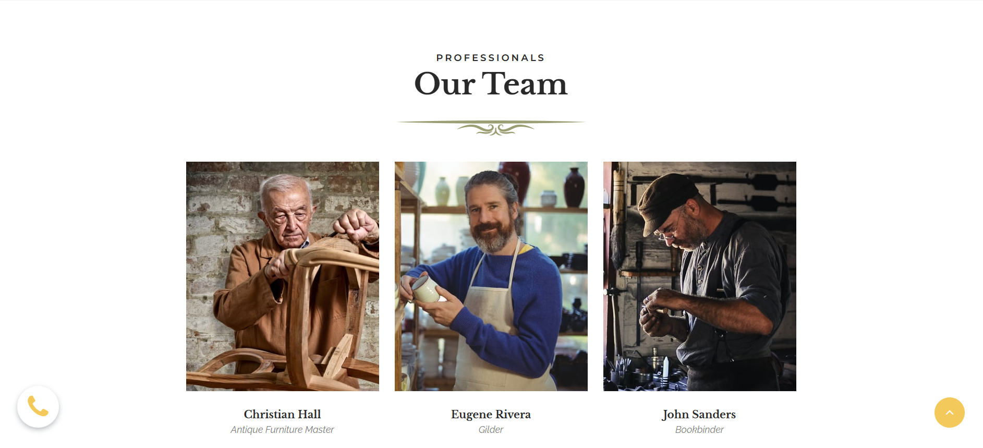

### Our Partner Section



### Contact Form Section

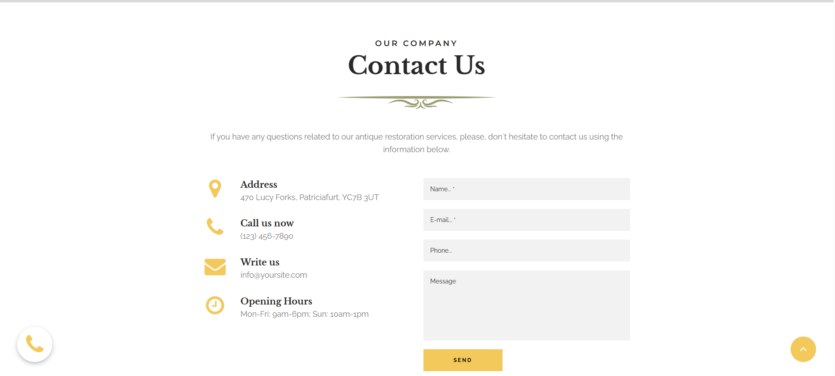

### Footer and Map Section

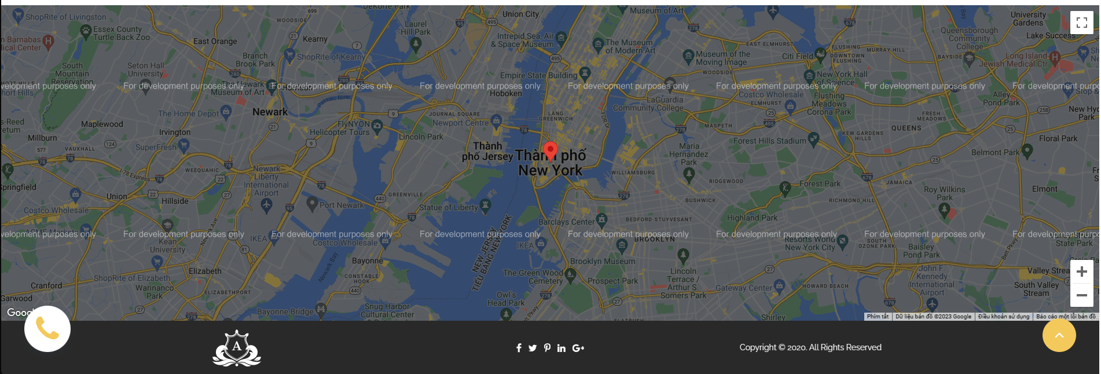

# REVIEW 3

## TASK SHEET REVIEW 3

|  |  |  |  |  |
| --- | --- | --- | --- | --- |
| **No** | **Page Name** | **Begin Date** | **TeamMate Name** | **Notes** |
| **Home Pages** | | | | |
| 01 | Navbar | 05/7/2023 | Le Viet Hai Duong  Quang Dai Vi |  |
| 02 | Home Title | Quang Dai Vi |  |
| 03 | Introduct | Nguyen Ngoc Thanh Chuong |  |
| 04 | Ads Section | Nguyen Ngoc Thanh Chuong |  |
| 05 | Lastest Work Section | Nguyen Ngoc Thanh Chuong |  |
| 06 | Gallery | Le Viet Hai Duong |  |
| 07 | Sevice Section | Le Thien |  |
| 08 | Testimonials Section | Le Thien |  |
| 09 | Team and Experts Section | Le Thien |  |
| 10 | Contact From Section | Quang Dai Vi |  |
| 11 | Map Section | Le Viet Hai Duong |  |
| 12 | Footer Section | Le Viet Hai Duong |  |

|  |  |
| --- | --- |
| **Date:** | |
| Signature of Instructor:  **MS. LE MONG THUY** | Signature of Team Leader:  **Le Viet Hai Duong** |